Output stationary:
$$GLB usage:$$
$$in feature=M×(K×3)×\left(4\right) bytes$$
$$weight=(K×3)×(N×4)×\left(4\right) bytes$$
$$psum=B×(N×4)×\left(4\right) bytes$$
$$DRAM:$$
$$DRAM reads for in_{f}=\left\lceil \frac{out_{f}}{N×4}\right\rceil ×\left\lceil \frac{in_{f}}{K×3}\right\rceil ×\left\lceil \frac{B}{M}\right\rceil ×\left(M×K×3×4\right) bytes$$
$$DRAM reads for weight= \left\lceil \frac{out_{f}}{N×4}\right\rceil ×\left\lceil \frac{in_{f}}{K×3}\right\rceil ×\left(K×N×12×4\right)bytes$$
$$DRAM writes for psum=\left\lceil \frac{out_{f}}{N×4}\right\rceil ×B×(N*4)×\left(4\right) bytes$$
$$GLB:$$
$$GLB reads for in_{f}=\left\lceil \frac{out_{f}}{N×4}\right\rceil ×\left\lceil \frac{in_{f}}{K×3}\right\rceil ×\left\lceil \frac{B}{M}\right\rceil ×\left\lceil \frac{M}{mode}\right\rceil ×\left\lceil \frac{K}{tk}\right\rceil ×\left\lceil \frac{N}{tn}\right\rceil ×\left( mode×tk×3×4 \right) bytes$$
$$tile for in_{f}=mode×tk×3×4 bytes$$
$$GLB reads for weight= \left\lceil \frac{out_{f}}{N×4}\right\rceil ×\left\lceil \frac{in_{f}}{K×3}\right\rceil ×\left\lceil \frac{B}{M}\right\rceil ×\left\lceil \frac{M}{mode}\right\rceil ×\left\lceil \frac{K}{tk}\right\rceil ×\left\lceil \frac{N}{tn}\right\rceil ×\left(tk×tn×12×4\right) bytes$$
$$tile for weight=tk×tn×12×4 bytes$$
$$GLB reads for psum=\left\lceil \frac{in_{f}}{K×3}-1\right\rceil ×\left\lceil \frac{out_{f}}{N×4}\right\rceil ×\left\lceil \frac{B}{M}\right\rceil ×\left\lceil \frac{M}{mode}\right\rceil ×\left\lceil \frac{N}{tn}\right\rceil ×\left(mode×tn×4×4\right) bytes$$
$$GLB writes for psum=\left\lceil \frac{in_{f}}{K×3}\right\rceil ×\left\lceil \frac{out_{f}}{N×4}\right\rceil ×\left\lceil \frac{B}{M}\right\rceil ×\left\lceil \frac{M}{mode}\right\rceil ×\left\lceil \frac{N}{tn}\right\rceil ×\left(mode×tn×4×4\right)bytes$$
$$tile for psum=tn×4×4 bytes$$
$$where B:batch ;mode=1, 2, 3, 6 ;tn=8$$
$$when mode=1,tk=6;mode=2,tk=3;mode=3,tk=2;mode=6,tk=1$$

Weight stationary
$$GLB usage:$$
$$in feature=M×(K×3)×\left(4\right) bytes$$
$$weight=(K×3)×(N×4)×\left(4\right) bytes$$
$$psum=B×(N×4)×\left(4\right) bytes$$
$$DRAM:$$
$$DRAM reads for in_{f}=\left\lceil \frac{out_{f}}{N×4}\right\rceil ×\left\lceil \frac{in_{f}}{K×3}\right\rceil ×\left\lceil \frac{B}{M}\right\rceil ×\left(M×K×3×4\right) bytes$$
$$DRAM reads for weight= \left\lceil \frac{out_{f}}{N×4}\right\rceil ×\left\lceil \frac{in_{f}}{K×3}\right\rceil ×\left(K×N×12×4\right)bytes$$
$$DRAM writes for psum=\left\lceil \frac{out_{f}}{N×4}\right\rceil ×B×(N*4)×\left(4\right) bytes$$
$$GLB:$$
$$GLB reads for in_{f}=\left\lceil \frac{out_{f}}{N×4}\right\rceil ×\left\lceil \frac{in_{f}}{K×3}\right\rceil ×\left\lceil \frac{B}{M}\right\rceil ×\left\lceil \frac{M}{mode}\right\rceil ×{\left(\left\lceil \frac{K}{tk}\right\rceil \right)}^{2}×\left\lceil \frac{N}{tn}\right\rceil ×\left( mode×tk×3×4 \right) bytes$$
$$tile for in_{f}=mode×tk×3×4 bytes$$
$$GLB reads for weight= \left\lceil \frac{out_{f}}{N×4}\right\rceil ×\left\lceil \frac{in_{f}}{K×3}\right\rceil ×\left\lceil \frac{B}{M}\right\rceil ×\left\lceil \frac{K}{tk}\right\rceil ×\left\lceil \frac{N}{tn}\right\rceil ×\left(tk×tn×12×4\right) bytes$$
$$tile for weight=tk×tn×12×4 bytes$$
$$GLB reads for psum=\left\lceil \frac{in_{f}}{K×3}-1\right\rceil ×\left\lceil \frac{out_{f}}{N×4}\right\rceil ×\left\lceil \frac{B}{M}\right\rceil ×\left\lceil \frac{M}{mode}\right\rceil ×\left\lceil \frac{K}{tk}\right\rceil ×\left\lceil \frac{N}{tn}\right\rceil ×\left(mode×tn×4×4\right) bytes$$
$$GLB writes for psum=\left\lceil \frac{in_{f}}{K×3}\right\rceil ×\left\lceil \frac{out_{f}}{N×4}\right\rceil ×\left\lceil \frac{B}{M}\right\rceil ×\left\lceil \frac{M}{mode}\right\rceil ×\left\lceil \frac{K}{tk}\right\rceil ×\left\lceil \frac{N}{tn}\right\rceil ×\left(mode×tn×4×4\right)bytes$$
$$tile for psum=tn×4×4 bytes$$
$$where B:batch ;mode=1, 2, 3, 6 ;tn=8$$
$$when mode=1,tk=6;mode=2,tk=3;mode=3,tk=2;mode=6,tk=1$$

Input stationary
$$GLB usage:$$
$$in feature=M×(K×3)×\left(4\right) bytes$$
$$weight=(K×3)×(N×4)×\left(4\right) bytes$$
$$psum=B×(N×4)×\left(4\right) bytes$$
$$DRAM:$$
$$DRAM reads for in_{f}=\left\lceil \frac{out_{f}}{N×4}\right\rceil ×\left\lceil \frac{in_{f}}{K×3}\right\rceil ×\left\lceil \frac{B}{M}\right\rceil ×\left(M×K×3×4\right) bytes$$
$$DRAM reads for weight= \left\lceil \frac{out_{f}}{N×4}\right\rceil ×\left\lceil \frac{in_{f}}{K×3}\right\rceil ×\left(K×N×12×4\right)bytes$$
$$DRAM writes for psum=\left\lceil \frac{out_{f}}{N×4}\right\rceil ×B×(N*4)×\left(4\right) bytes$$
$$GLB:$$
$$GLB reads for in_{f}=\left\lceil \frac{out_{f}}{N×4}\right\rceil ×\left\lceil \frac{in_{f}}{K×3}\right\rceil ×\left\lceil \frac{B}{M}\right\rceil ×\left\lceil \frac{M}{mode}\right\rceil ×\left\lceil \frac{K}{tk}\right\rceil ×\left( mode×tk×3×4 \right) bytes$$
$$tile for in_{f}=mode×tk×3×4 bytes$$
$$GLB reads for weight= \left\lceil \frac{out_{f}}{N×4}\right\rceil ×\left\lceil \frac{in_{f}}{K×3}\right\rceil ×\left\lceil \frac{B}{M}\right\rceil ×\left\lceil \frac{M}{mode}\right\rceil ×\left\lceil \frac{K}{tk}\right\rceil ×\left\lceil \frac{N}{tn}\right\rceil ×\left(tk×tn×12×4\right) bytes$$
$$tile for weight=tk×tn×12×4 bytes$$
$$GLB reads for psum=\left\lceil \frac{in_{f}}{K×3}-1\right\rceil ×\left\lceil \frac{out_{f}}{N×4}\right\rceil ×\left\lceil \frac{B}{M}\right\rceil ×\left\lceil \frac{M}{mode}\right\rceil ×\left\lceil \frac{K}{tk}\right\rceil ×\left\lceil \frac{N}{tn}\right\rceil ×\left(mode×tn×4×4\right) bytes$$
$$GLB writes for psum=\left\lceil \frac{in_{f}}{K×3}\right\rceil ×\left\lceil \frac{out_{f}}{N×4}\right\rceil ×\left\lceil \frac{B}{M}\right\rceil ×\left\lceil \frac{M}{mode}\right\rceil ×\left\lceil \frac{K}{tk}\right\rceil ×\left\lceil \frac{N}{tn}\right\rceil ×\left(mode×tn×4×4\right)bytes$$
$$tile for psum=tn×4×4 bytes$$
$$where B:batch ;mode=1, 2, 3, 6 ;tn=8$$
$$when mode=1,tk=6;mode=2,tk=3;mode=3,tk=2;mode=6,tk=1$$

Diagram
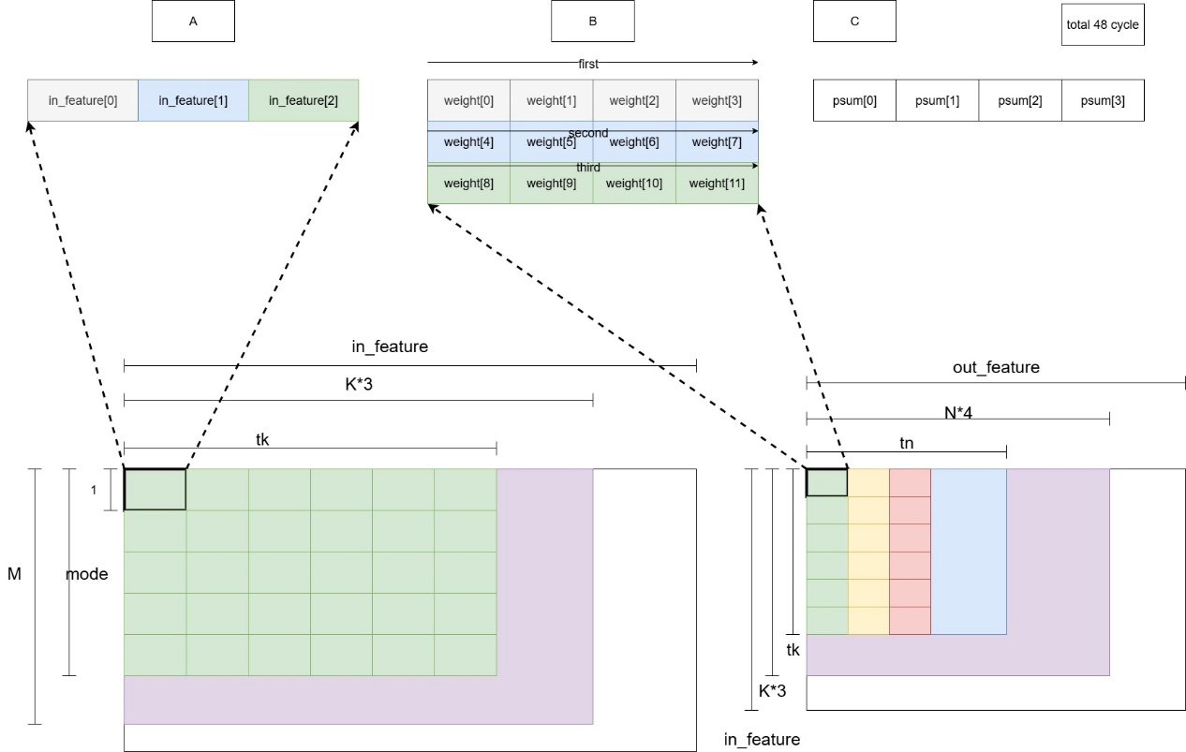

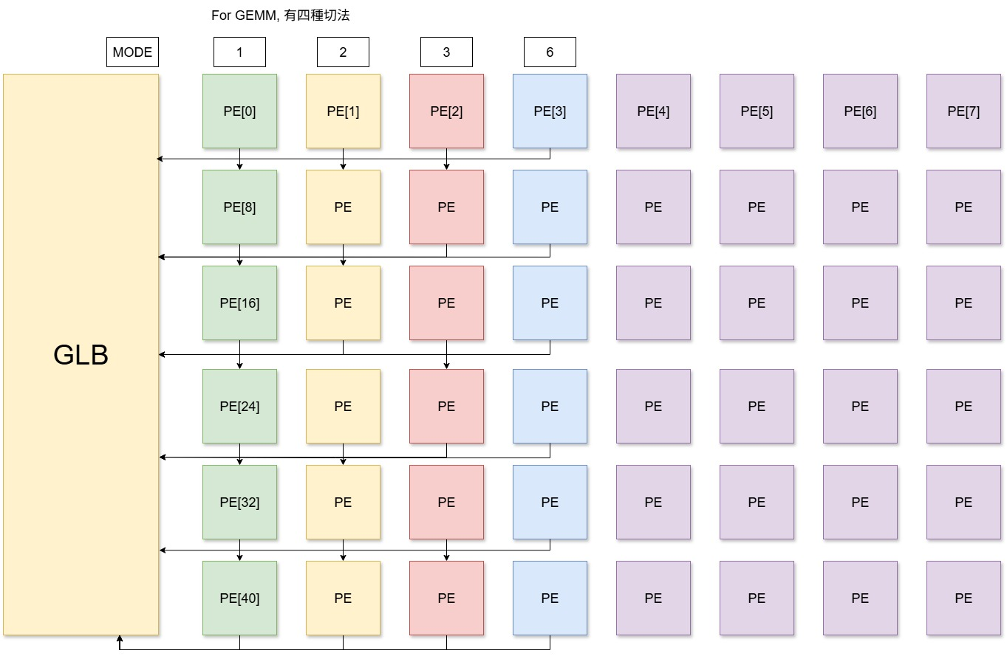
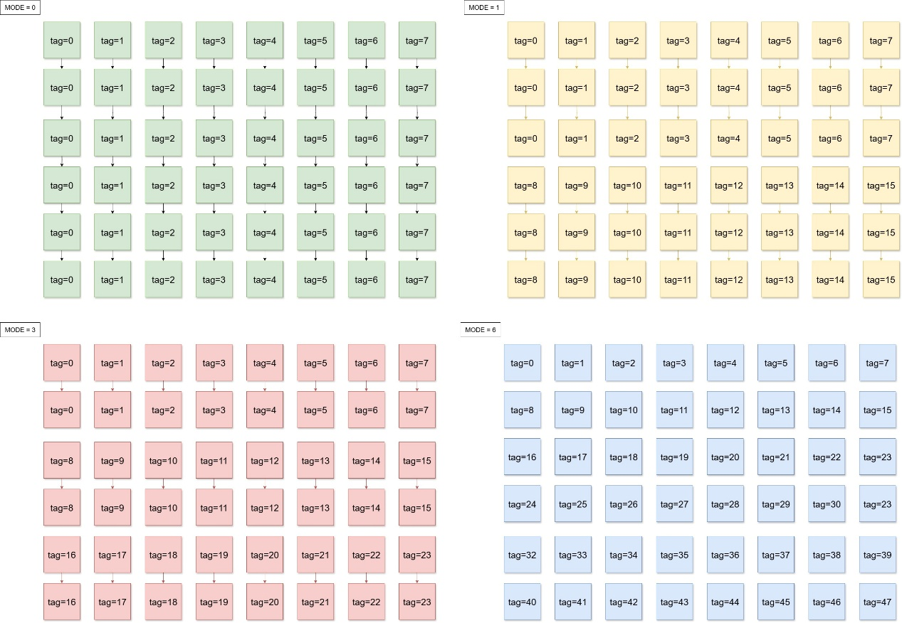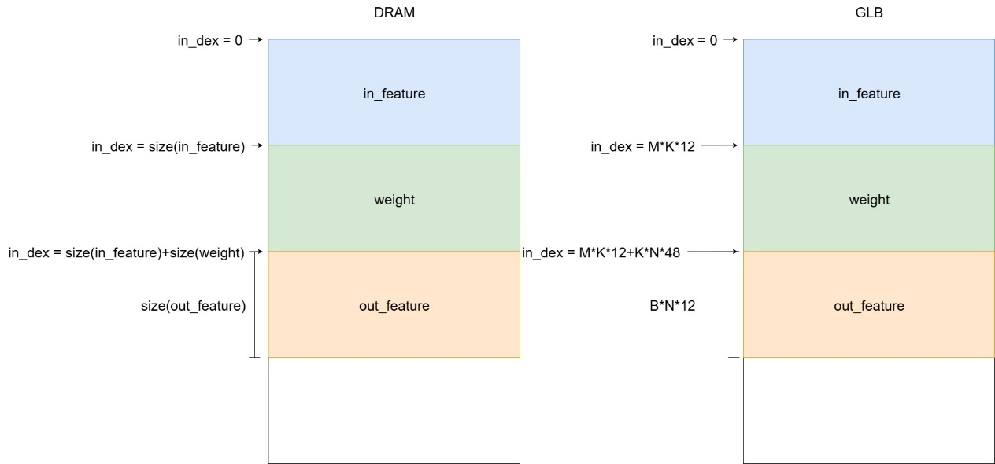

Src
MEM
Memory.cpp：memory的一些功能，DRAM和GLB預計都用這個的，只是access cycle的數量不一樣
Mem_test.cpp：memory在模擬的時候的用法，由read_data()和write_data()作為base做後續的修改
Testbench
tb_pe_array
GEMV_no_mem.cpp: 還沒加DRAM和GLB，可以直接存取data（最簡單）
GEMM_no_mem.cpp：直接從前面GEMV做小修改（簡單）
GEMV_with_mem.cpp：加上DRAM和GLB，要多計算cycle（難）
GEMM_with_mem.cpp：最終目標（最難）

